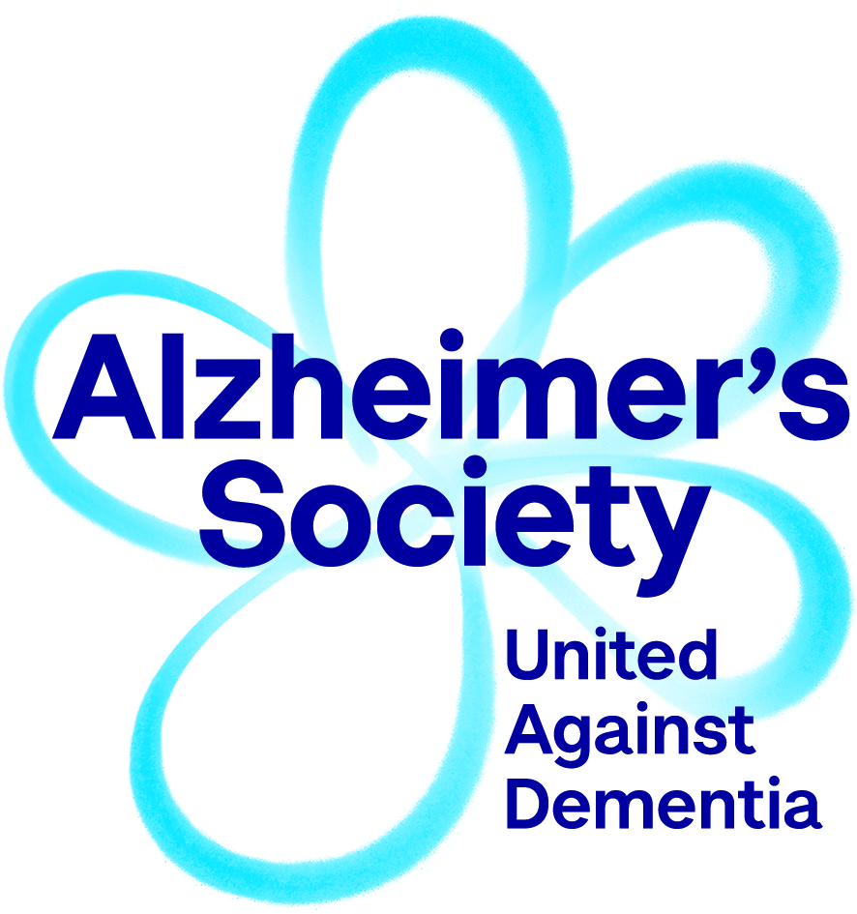

Expression of interest:
Alzheimer’s Society Grant Review Process

Thank you for your interest in Alzheimer’s Society. To be considered for membership of our Expert Review College or a position on the Grant Advisory Board please complete this expression of interest form and return it to grantenquiries@alzheimers.org.uk.

1. About you:

Name
Title
Institute (primary)
Any other institute affiliations (for instance honorary positions)

2. Indicate which part of the grant review process you are interested in (please X in those that apply):

Expert Review College Member |  | Grant Advisory Board Member

3. Expertise:

Please list the areas of expertise that you can provide comment on with regard to grant applications (see below for examples):
Amyloid biology, animal models, biomarkers, clinical trials, developmental biology, drug discovery, genetics, tau biology, machine learning, neuroinflammation, neuroimaging, neuropathology, data science, engineering, care home research, epidemiology, health economics, hospital research, implementation research, nursing research, public health, qualitative research, service evaluation, statistics, social research

4. Personal statement:

Please use this space to provide any further comment about your motivations or interest in joining our grant review process.

5. Please attach a copy of your CV (any format).

