Partnership Application Form | 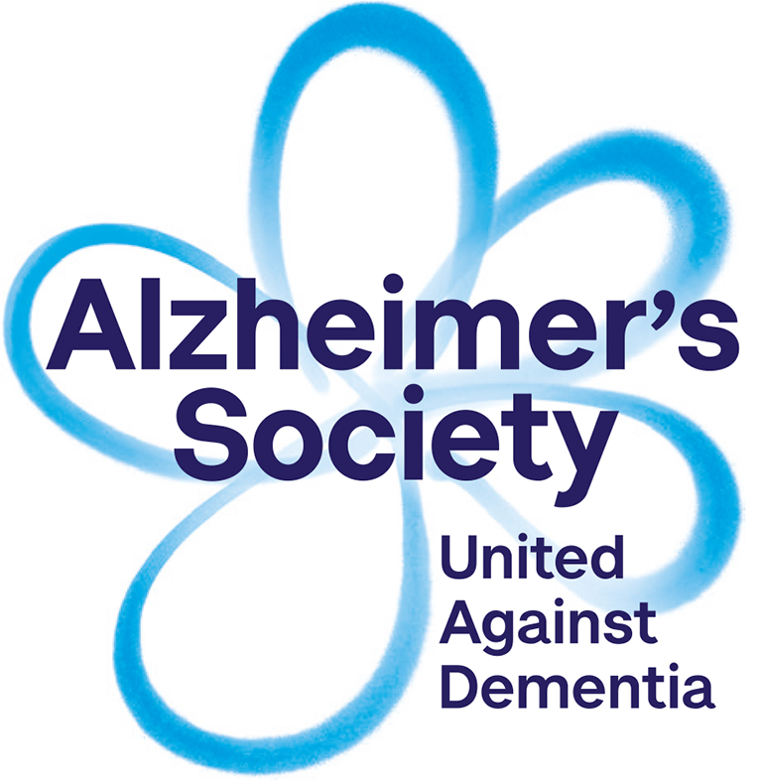
We strongly recommend that you read the separate guidance document before filling in this form

Please note if your research is funded by Alzheimer’s Society and you require support from us please contact grantenquiries@alzheimers.org.uk, you do not need to complete this form.

Principal Applicant (your details)
The Principal Applicant must be sponsored by a UK based recognised higher education learning institute (e.g. a University)
And must be studying at PhD level OR have already achieved a PhD or higher Clinical qualification.
Full name
Title
Post held
Department and address
Telephone
E-mail

Please list other applicants and institutes involved in the application | Applicant | Institute
Title of research project

Have you already contacted anyone within Alzheimer’s Society about the proposal?
☐ Yes (If yes, please provide name(s) and dates)
☐ No

Please indicate which classification category your research falls under:
<Click Here>

Brief summary of project (Max 500 words)
Please include;
- project aims and objectives, methodology (including recruitment, if you are asking AS to support recruitment),
- details of future plans for implementation and dissemination,
- Please also outline (if known) how your research relates to the work of Alzheimer’s Society.

Is ethical approval in place?
☐ Yes
☐ Not yet but we are in the process of applying
☐ No plans for ethical approval; please explain the reasons why ethical approval is not required for the research below

Is funding already in place?
☐ Yes: Please proceed to Section Two

☐ No: Please proceed to Section One

SECTION ONE: Pre-application

What is the funding scheme you are applying to? (Please provide a hyperlink to their website)
When is the funding deadline?
When will you know the outcome of your funding application?

Please indicate the type of support you would like from Alzheimer’s Society;

- Enabling people affected by dementia to advise as the plans for research are being developed  - Enabling Alzheimer’s Society staff to advise as the plans for research are being developed  (c) Letter of support outlining our intentions to support your research should you be successful in gaining funding  If you ticked (a) or (b) please respond to the following (we are unable to process your request unless you are specific);  - Please explain what specifically you hope Alzheimer’s Society will provide?  - Please add details of the kind of expertise you would find helpful  - When would you like involvement to start and when do you expect it to end?  - Do you have any budget available to support this activity? Please provide details below. (We recommend the use of the INVOLVE guidance for creating a budget for Patient and Public Involvement. Their Involvement Cost Calculator provides suggested costing for a range of activities.) | ☐  ☐  ☐

SECTION TWO: Once funding is in place

Please indicate the type of support you would like from Alzheimer’s Society;
(a) Enabling people affected by dementia to advise and support delivery  - Please explain why you want to involve people affected by dementia in your research  - Please explain how you want to involve people affected by dementia?  - When would you like involvement to start and when do you expect it to end?  - Do you have any budget available to support this activity? Please provide details below. (We recommend the use of the INVOLVE guidance for creating a budget for Patient and Public Involvement. Their Involvement Cost Calculator provides suggested costing for a range of activities.) | ☐
(b) Enabling people affected by dementia to become research participants  - Please detail your experience of working with people with dementia or other vulnerable groups  - Please indicate which group of people you are looking for and how many (add numbers against each point below);  ☐ People with dementia  ☐ Carers  ☐ Former carers  ☐ Family members  ☐ Other, please specify_____________________________  - Please list the areas where you are aiming to recruit participants (i.e. town/city/region – please be as specific as possible).  - Please indicate when you would like recruitment support to start and end  - Please ensure you have attached the following supporting documents:  ☐ Consent forms  ☐ Information sheets  ☐ Questionnaires  ☐ Interview templates  Please note, if during the course of the research you will be spending time with our service users without our staff being present then you will need to send us proof of DBS clearance for working with vulnerable adults when you send this application form to us. | ☐
(c) Enabling Alzheimer’s Society staff to become members of the project advisory group  - Please add details of the kind of specialty/ expertise would be beneficial for the advisory group?  - When would you like involvement to start and when do you expect it to end?  - If applicable, do you have any budget available to support this activity? If so, please provide details below. | ☐
(d) Involving Alzheimer’s Society to help engage decision makers  Please explain what specifically you hope Alzheimer’s Society will provide? | ☐
(e) Involving Alzheimer’s Society to become delivery/implementation partners  Please explain what specifically you hope Alzheimer’s Society will provide? | ☐
If you have other suggestions for support, please add details below;

For support with dissemination please see details of our dissemination grants scheme for more information

Why do you consider Alzheimer’s Society to be an appropriate partner for your research proposal?

Please note, if your partnership application is successful, Alzheimer’s Society expect the following in return for our support ;

- Appropriate acknowledgement of contributions to the research from people affected by dementia and or our staff i.e. in publications and other dissemination materials should be planned.

- Regular updates on the progress of your research. Feedback about the outcomes of your research and the impact of staff/service user/volunteer contributions should also be planned - please outline how you intend to do this in the space below

- Contributions to impact reports, and evaluations of the partnership process
Date application submitted:

How to submit your partnership application

Please email this form and any other information (i.e. draft proposal, project outline) which may assist us in understanding your proposal better to: ResearchPartnerships@alzheimers.org.uk

What will happen next?

Your application will be reviewed against the criteria document available on the partnerships page of our website in line with the goals of our research strategy as well as the capacity of our staff and volunteers to support your request

Alzheimer’s Society will keep your information confidential and not use it for any other use except for delivering, managing and evaluating our Research Partnership process.

